**Practice project**

Searching for a Specific User and Updating the User Information

Output:

Search form

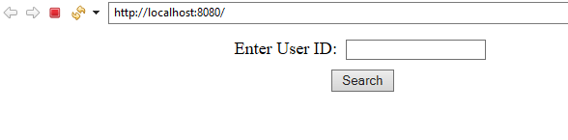

Edit form

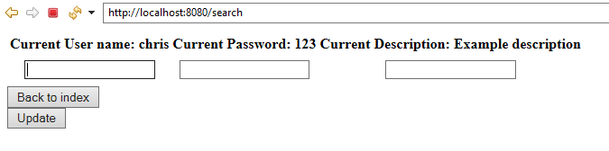

Changing values

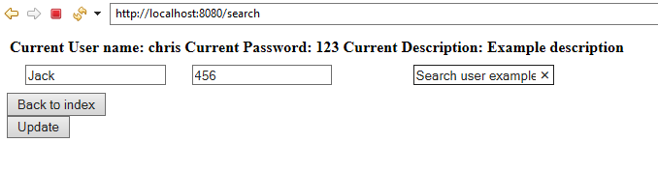

Update form

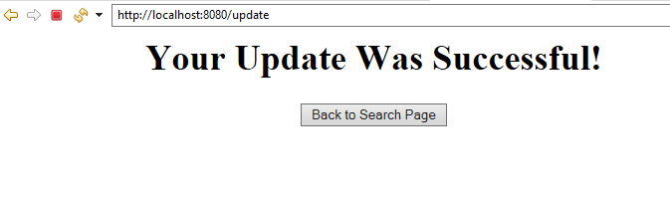

Before editing(In database)

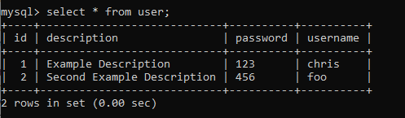

After editing(In database)

